29.57: 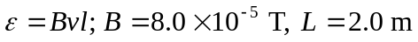
Use 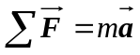 applied to the satellite motion to find the speed of the satellite.
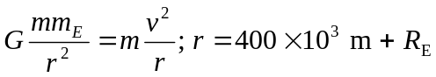
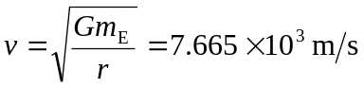
Using this gives 